**Neha Malhotra**  **R.L. Institute M: 9416974837**

**Max Time : 1 hr** **Class = 12th Biology Test**  **Max Marks : 25**

**HUMAN REPRODUCTION – 1**

1. Multiple choice questions : [ 1 X 5 = 5]
2. The leydig cells are source of

|  |  |  |  |
| --- | --- | --- | --- |
| a) fructose | b) androgens | c) progesterone | d) mucus |

1. Which among the following has 23 chromosomes ?

|  |  |  |  |
| --- | --- | --- | --- |
| a) spermatogonia | b) zygote | c) secondary oocyte | d) oogonia |

1. The vas deferens receives duct from the seminal vesicle and opens into urethra as

|  |  |  |  |
| --- | --- | --- | --- |
| a) epididymis | b) ejaculatory duct | c) efferent ductule | d) ureter |

1. Urethral meatus refers to

|  |  |
| --- | --- |
| a) urinogenital duct | b) opening of vas deferens into urethra |
| c) external opening of the urinogenital duct | d) muscles surrounding the urinogenital duct |

1. Which of the following statements is incorrect ?

a) GnRH stimulates the secretion of FSH and LH

b) LH stimulates the leydig cells to secrete androgens

c) FSH acts on the sertoli cells and stimulates spermiogenesis

d) None of these

1. What are the location and function of sertoli cells in humans. [ 1 ]
2. What are the major component of seminal plasma ? [ 1 ]
3. Name the important mammary gland secretions that help in resistance of the new born baby. [ 1 ]
4. Name the embryonic stage that gets implanted in the uterine walls of a human female. [ 1 ]
5. Given below are the stages in human reproduction. Write them in correct sequential order. [ 1 ]

Insemination , Gametogenesis , Fertilization , Parturition , Gastrulation , Implantation

1. Define spermiogenesis and spermiation. [ 2 ]
2. Draw a diagram of a mature human sperm. Label the following parts in it and write their functions.

|  |  |  |
| --- | --- | --- |
| a) Acrosome | b) Nucleus | c) Middle piece [ 3 ] |

1. What is spermatogenesis? Give a brief account of spermatogenesis. [ 3 ]
2. Draw a labelled diagram of the human female reproductive system. [ 3 ]
3. Study the graph given below related with menstrual cycle of human female. [ 4 ]

(a) Identify ovarian hormones X and Y mentioned in the graph and specify their source.

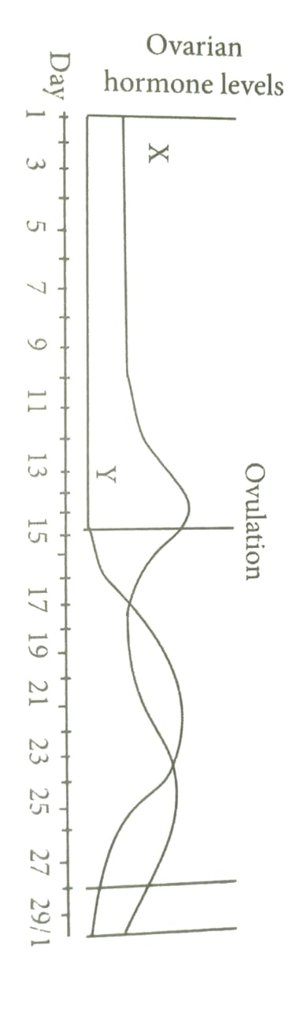

(b) Correlate and described the uterine events that take place according to the ovarian hormone levels X and Y mentioned in graph on : (i) 6-15 days (ii) 16 – 25 days (iii) 26-28 days (when ovum is not fertilized)